Setup and Instructions for Red/Green/White
5mm LEDs Light Ring Demonstrator

> Plug power supply barrel plug into jack on controller.
> Plug 4-pin connectors together (align arrows).
> Plug power supply into an AC outlet.
> Turn off any lights and darken the room.
> Provide a black background under the Ferrocell for
increased contrast and brightness.

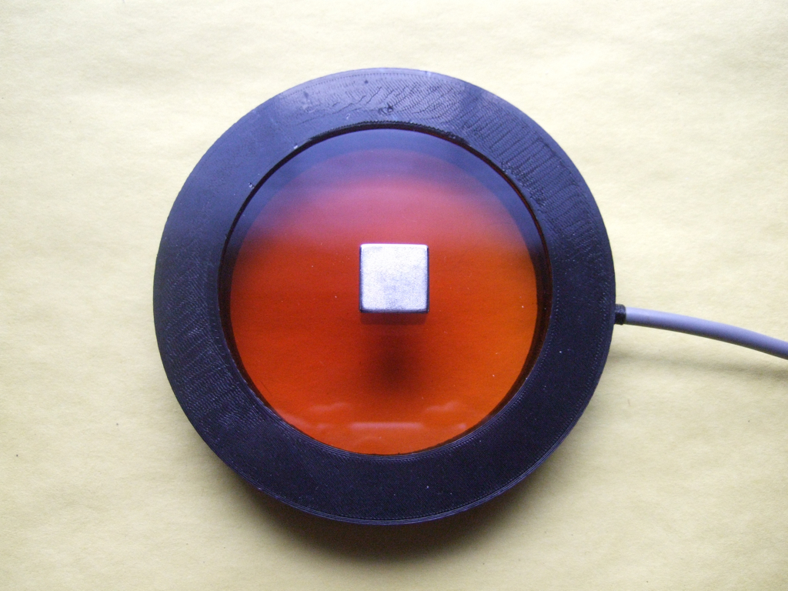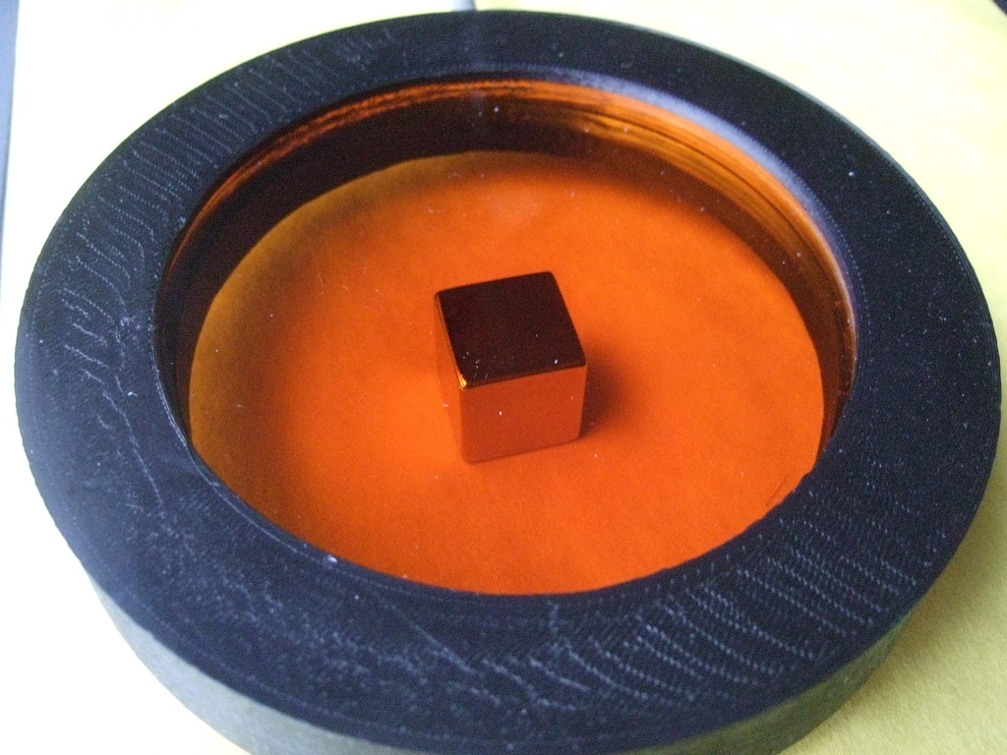
Place the magnet on top or bottom of the cell.

Flip, turn and move magnet. See how the field changes in proportion to the magnetic field alignment.

Wait a 10-30 seconds for image to manifest. Move magnets position often. Resting magnet in one position for long periods of time may burn the inside surface of the glass, creating a blurred view in the affected area.
Check the forum for more experiments and tips: http://ferrocell.freeforums.net/
……………………………………………………………………………………………………………………………...
> Caution: Very strong magnets! Use care -avoid ferrous metal surfaces. May shatter.
> Do not place magnets of opposite polarity on both sides of Ferrocell at the same time or damage to the seal may occur.
> Do not leave magnet in one position on Ferrocell glass for extended periods of time or nanoparticles will ‘burn’ an image into the glass and will take a few days to dissipate.
> Clean glass surfaces with glass cleaner and lint free towel or lens paper to remove smudges or fingerprints.
> Your Ferrocell has a two (2) year replacement (or repair) warranty. You only need to pay shipping back to us if cell becomes defective.
> Any questions, please contact info@ferrocell.us for help.

